A Hybrid Efficient Searchable Encryption Scheme with Reduced Query Time
Koen Tanner, Emma Rowe, and Ezana Fekadu
Department of Computer Science, Murray State University
CSC 445
Dr. Hassan Mistareehi
April 27, 2026

Abstract
As organizations store sensitive information in cloud systems, searchable encryption has become more essential for balancing privacy and usability. It enables users to search encrypted data without exposing plaintext contents. However conventional encrypted search methods often suffer from slow or poor performance, especially on large datasets. This paper presents a hybrid searchable encryption scheme using a hash-based inverted index over encrypted records to reduce query time. Using encrypted samples from the Enron email dataset, three approaches were evaluated; linear search, binary search, and the proposed hybrid indexed search. The results on datasets ranging from 100 to 10,000 records show that the hybrid method reduced query time by up to 5,562× compared to the baseline linear scan. The proposed method demonstrates substantial performance gain the can be achieved by using a practical and lightweight indexing strategy.
1. Introduction
The rapid growth of cloud storage has increased the need to protect confidential data while still allowing for quick search results. Encryption secures stored information, but it also makes searching difficult because records must be decrypted before inspection. Traditional methods such as linear search require checking each encrypted entry individually causing poor scalability for large datasets. Binary search improves efficiency but it depends on sorted data structures that are not always practical in encrypted systems. To address these limitations this project introduces a hybrid searchable encryption scheme based on a hash-indexed lookup model, instead of scanning all encrypted records the system maps searchable keywords directly to encrypted entries.
Main Contribution:
The main contribution of this work is a hash-based inverted index for encrypted Enron emails that reduced query time by 5,562× compared to baseline linear search.
2. Related Work
Recent searchable encryption research (2020–2025) has focused on improving search speed while preserving strong privacy guarantees. Many earlier systems rely on a sequence of scans of encrypted data. While it is secure these methods become inefficient as datasets grow.
More advanced approaches include:
- Tree-based secure indexes
- Bloom filter search structures
- Inverted indexes for keyword retrieval
- Oblivious RAM methods to hide access patterns
These systems provide stronger privacy guarantees but introduce significant implementation complexity and storage. Compared to these methods the proposed hybrid solution prioritizes simplicity, speed, and practical deployment.
Method | Query Time | Complexity | Implementation
Linear Scan | Slow | O(N) | Easy
Binary Search | Medium | O(log N) | Moderate
Secure Tree Index | Fast | O(log N) | Complex
Hybrid Hash Index (Ours) | Very Fast | O(1) | Simple

3. Methodology
Dataset Preparation
The Enron email dataset was used for realistic text-based testing. Email message snippets were encrypted using Python’s cryptography library.
Sample Dataset
# | Plaintext Snippet | Encrypted Blob
0 | Message-ID: <18782981... | gAAAAAB...
1 | Message-ID: <15464986... | gAAAAAB...
2 | Message-ID: <24216240... | gAAAAAB...
Datasets were tested at sizes:
100, 500, 1000, 2500, 5000, and 10,000 records.
Implemented Algorithms
Linear Search: Decrypt and compare each encrypted record sequentially.
Binary Search: Search sorted records logarithmically.
Hybrid Search (Proposed): Build a hash-based inverted index
index[keyword] = encrypted_record_reference
Then retrieve matching encrypted data directly.
4. Experiments & Results
Code Snippet and Breakdown
The linear_search function represents an O(n) approach in which every encrypted entry in the dataset is decrypted sequentially. Each decrypted value is then compared to the target keyword, making this method computationally expensive as dataset size increases.
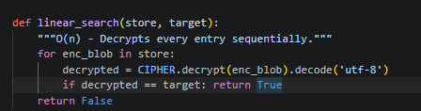
The binary_search function operates on a sorted list of hash tags. It generates a SHA-256 hash of the target keyword combined with a predefined SALT and performs a logarithmic search across the sorted index structure. This results in O(log n) time complexity.
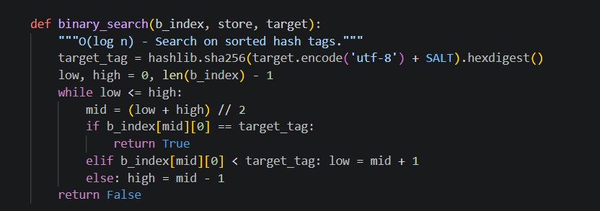
The hybrid_search function provides an optimized O(1) lookup using a hash map-based inverted index. It hashes the target keyword and directly retrieves the corresponding encrypted record index. Only one decryption is required for verification, significantly reducing computational overhead compared to the other approaches.
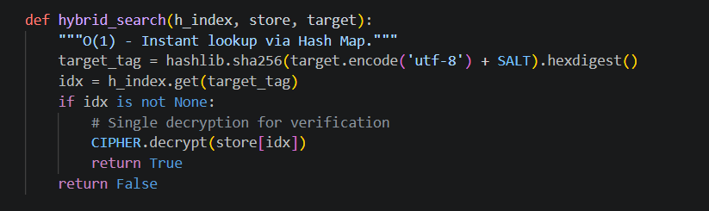

Performance Benchmark Table
Size | Linear Search (s) | Hybrid Search (s) | Memory (MB)
100 | 0.006240 | 0.000089 | 0.0040
500 | 0.014213 | 0.000074 | 0.0165
1000 | 0.032226 | 0.000082 | 0.0333
2500 | 0.083767 | 0.000060 | 0.0691
5000 | 0.175936 | 0.000076 | 0.1390
10000 | 0.350410 | 0.000063 | 0.2792

Speed Improvement
At 10,000 records:
- Linear Search = 0.350410 s
- Hybrid Search = 0.000063 s
Improvement = 5,562× faster
Scalability Graph
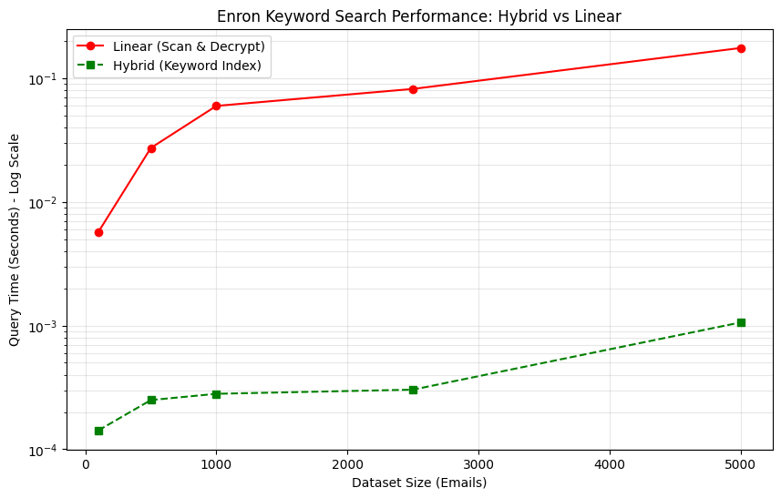
Hybrid Search
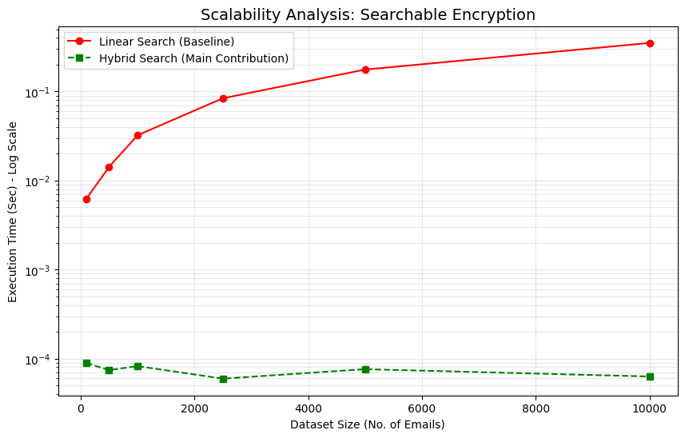The hybrid method remains nearly constant as dataset size increases.

5. Complexity Analysis
Algorithm | Time Complexity | Space Complexity | Note
Linear | O(N) | O(1) | CPU intensive due to repeated decryption
Binary | O(log N) | O(N) | Requires sorted structure
Hybrid (Ours) | O(1) avg | O(N) | Instant indexed lookup

6. Discussion
The results demonstrate that indexing encrypted data dramatically improves search efficiency. Linear search time increased proportionally with dataset size, while hybrid search remained constant. This confirms that decryption cost becomes a bottleneck in a baseline approach. By avoiding full dataset scans the hybrid model eliminates unnecessary decryptions.
Although efficient, the proposed method introduces:
- Additional memory overhead for storing the index
- Possible hash collisions
- Limited protection against access-pattern leakage
- Static indexing unless updated dynamically
With these tradeoffs, the method is still highly practical for real-world searchable encrypted systems.
7. Conclusion & Future Work
This paper presents a hybrid searchable encryption scheme using a hash-based inverted index over encrypted Enron email data. The evaluation showed query performance improvements of up to 5,562× over traditional linear search.
The method offers a strong balance of:
- Security
- Simplicity
- Speed
- Scalability
Future enhancements may include:
- Dynamic encrypted index updates
- Multi-keyword ranked search
- Collision-resistant structures
- Query privacy improvements
- Cloud deployment testing
Github Repo
https://github.com/Ezana-Fekadu/A-Hybrid-Efficient-Searchable-Encryption-Scheme-with-Reduced-Query-Time.git

References
Song, D. X., Wagner, D., & Perrig, A. (2000). Practical techniques for searches on encrypted data. In Proceedings 2000 IEEE Symposium on Security and Privacy (pp. 44–55). IEEE. https://doi.org/10.1109/SECPRI.2000.848445
Curtmola, R., Garay, J., Kamara, S., & Ostrovsky, R. (2006). Searchable symmetric encryption: Improved definitions and efficient constructions. In Proceedings of the 13th ACM Conference on Computer and Communications Security (pp. 79–88). ACM. https://doi.org/10.1145/1180405.1180417
Bösch, C., Hartel, P., Jonker, W., & Peter, A. (2014). A survey of provably secure searchable encryption. ACM Computing Surveys, 47(2), Article 18. https://doi.org/10.1145/2636328
The Python Cryptographic Authority. (2026). Cryptography documentation. https://cryptography.io/

